**Between The Acts – The Legacy of Thomas H Hall**

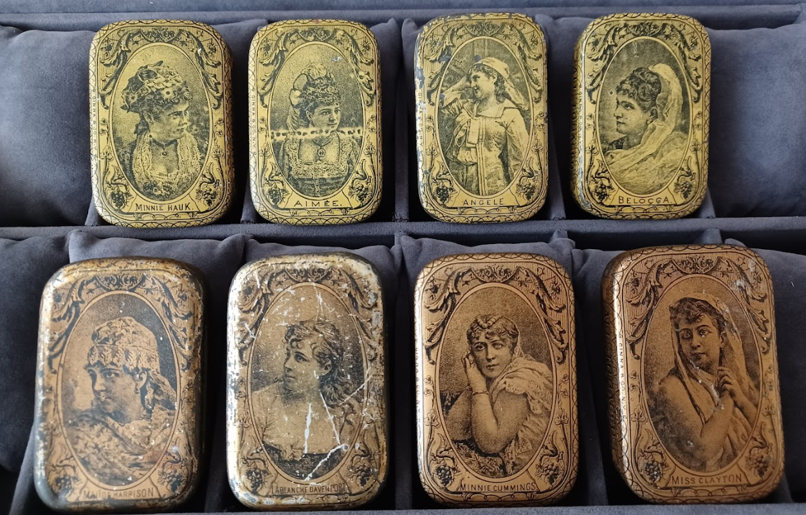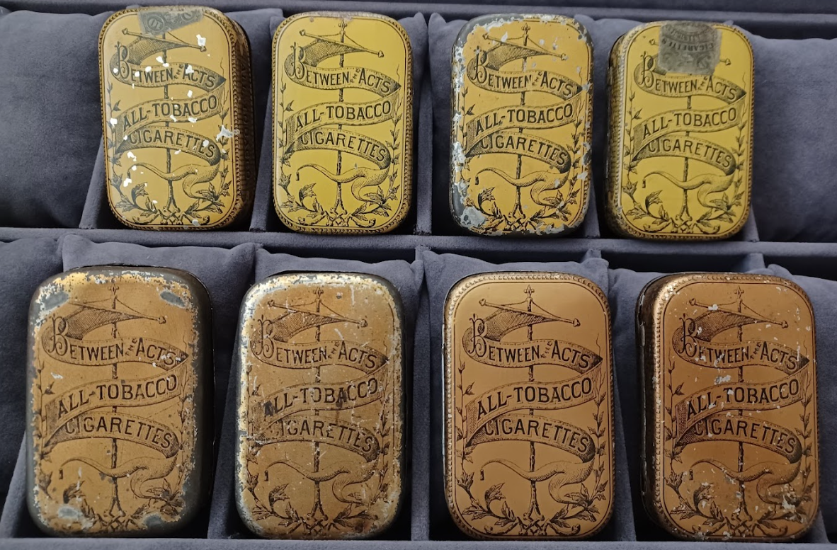

Between The Acts Pocket Tins – Thomas H Hall circa 1882-1884

I decided to write this article for a number of reasons, the main prompt coming after I had the pleasure and great joy in acquiring a set of nine extremely rare ‘Between The Acts’ (BTA) cigarette pocket tins made by Thomas H Hall. These were originally from the Jim Challenger collection and subsequently acquired by advanced pocket tin collector, Reylan Lange.

The Challenger/Lange collection of these nine pocket tins is simply unique. Finding one in any condition would need the patience of a saint and the luck of the Irish, but nine…………perhaps a lifetime, or two?? Another reason for embarking on this research is I felt that there would be interest from both British and American collectors alike. As this story will tell, Hall had close links to both countries.

Much is known about the cigarette cards that were placed in Halls famous BTA cigarette packs. In fact, there are many experts who are far more qualified than me in this area of collecting and one can find ample literature about the various card sets that came with Hall’s BTA cigarettes. However, I have not come across much in the way of research around Hall as an individual, his family and history. I wanted to know a little more about the man and his motivations, the influencers and experiences that made him one of the most successful and famous tobacco men in the history of this industry.

To know the man is to start at the very beginning, and even before. Perhaps it is less well known that Hall’s father, Joseph was an extremely successful and wealthy tobacco man himself. It was definitely Joseph’s influence on Thomas that made him into the man that he became so I shall start with the father before moving on to the son.

Joseph Hall was born in the tiny village of Shutford, England around 1810 / 1811. He left England when he was but seventeen years of age and emigrated to the US where he worked until setting up a retail store and factory on 80, Barclay Street, NYC in 1836. It was said at the time that tobacco manufacture was not regarded with much esteem and that most makers of the period produced second class tobaccos as compared to those from Havana, which was the benchmark of the day. Hall Snr however worked hard to achieve excellence through the application of a few fundamental rules when producing tobacco. The first and foremost having the best raw materials he could get his hands on. Second, ensuring care and attention in their preparation and use. Third, only employing a trained and skilled workforce. Finally, ensuring that all labourers were observed carefully and managed well. It is said that no tobacco manufacturer that followed did not utilise one or more of Hall Snr’s guiding principles in their production. During his forty-year career, Hall Snr also made another valuable contribution to the trade and that was to discover the value of tobaccos from Connecticut in the manufacture of cigars, chiefly as a replacement to Havana tobaccos. The rise in popularity of Connecticut tobaccos over the following decades was due in no small part to Hall Snr’s influence and ingenuity in its identification. He travelled extensively during his career, maintaining his links with Europe and revisiting his birthplace numerous times. He was a learned man, of intellect, faithful and positive with integrity. These are virtues he must have bestowed onto this son. Hall Snr retired in 1876, relinquishing his empire to his eldest son, Thomas, but continued to travel in his retirement. His last trip back to England was in May 1879. However by this time his health had already begun to fail and was bedridden for the last four months of his life until he passed away in June 1880.

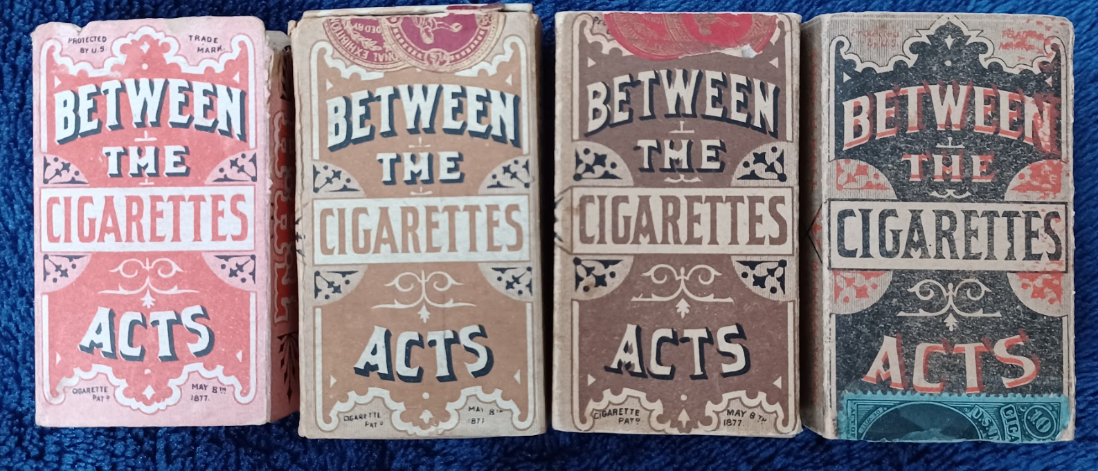

Between The Acts Cigarettes – 1880s

By the time of Joseph’s death, Thomas had already been running his father’s business for four years and had brought both an invigorated approach as well as advances, the main one being the manufacture of cigarettes. The history of manufacture of cigarettes in the US can very well be the subject of a number of articles but for the purposes of this article one can summarise very generally by saying that the sale of cigarettes in America did not start in earnest until the mid to late 1860s and even then these were brought in from abroad (Europe and S. America) and sold in bulk quantities to wholesalers and distributors locally. Tax laws were only changed in the late 1860s when the American Government realised that there was money to be made in this growing industry. Not until the early 1870s did one start to see the local growing and manufacture of cigarettes from the likes of Frances Kinney and his contemporaries. Perique cigarettes from New Orleans started around the same time in the early to mid 1870s. In my view, Thomas Hall was one of the early visionaries and pioneers of cigarette manufacture with the introduction of his legendary ‘Between The Acts’ all tobacco cigarettes at the beginning of 1877. Prior to this, the world of cigarette smoking consisted of small amounts of fragranced granulated or cut tobacco, rolled in either linen or rice paper, or corn husks in the case of Perique cigarettes. The transition between cigar smoking and cigarette smoking started during the 1870s, when men started appreciating the joys of cigarette smoke. Hall was quick to grasp the opportunities afforded by this change in tastes and brought both ‘Between The Acts’ and ‘Between the Scenes’ brands using only the finest Havana leaf tobacco. His manufacturing facility was more than capable in making the change to producing the best quality cigarettes but few were aware of the history behind the conception of this iconic brand. Hall had actually been producing an all tobacco cigarette as early as 1875 but only for his own personal consumption and free of charge to his circle of friends. He was of the view that paper-wrapped cigarettes were unwholesome and he sought to find a more acceptable alternative. The only issue with the all tobacco cigarette was the roughness of the tobacco wrapping and Hall felt that this would limit its uptake with the cigarette smoking population. However, an alternative from a competitor found favour with the public upon its release and this prompted Hall to change his mind and bring to market his own BTA cigarettes by which time he had managed to all but remove the roughness. Hall had pondered overnight with a Webster’s unabridged dictionary in hand to try and find a name for his new brand of cigarettes but to no avail. Despondent he went to work the next day and was visited by a famous literary gentleman who supplied him with a list of a dozen words after which he immediately exclaimed ‘By gracious, that must be in my dictionary, but I did not see it!’ Hall then christened his new brand ‘Between The Acts’ which was in vogue in Europe during that time. Male theatre goers used to take a break during the intermission for a smoke of weed in the theatre lobbies and hence the phrase was coined.

As an example of a period all-tobacco cigarette the picture below shows a pack from my collection called ‘The Continental’ which was made by a manufacturer in Worcester, Mass around 1879/1880. There is actually one cigarette left in the pack and you can see the roughness of the outer tobacco wrapping.

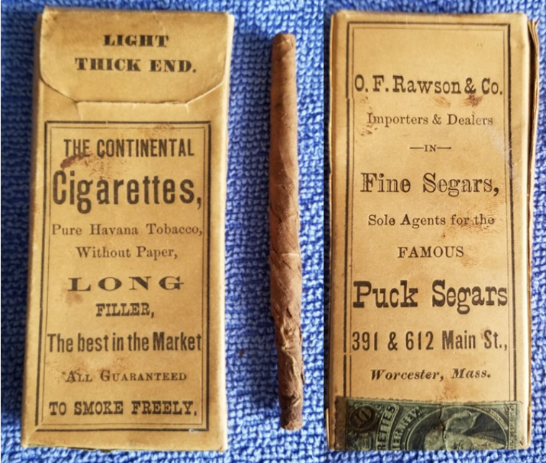

Continental all tobacco cigarettes – O F Rawson & Co circa 1879-1881

In November 1877 and really as an afterthought, Hall introduced his cigarette cards lithographed with pictures of theatrical actresses appearing in American stage at that time. The American public were entranced by Parisian Burlesque at the time and Hall thought that such gems of art might prove popular with the American public, which they did. Ladies that were included in the original release were names such as Henrietta Chanfrau, Fanny Davenport, Maggie Moore, Lydia Thomson and Maude Branscomb. Actress Mary Anderson even had one of the show cards framed and placed in her own home, such was the brilliance of the artistry. The firm producing the cigarette cards, Heppenheimer & Maurer were also asked to produce similar stone statuettes. English actresses were also included very soon after their American counterparts were released, and Hall even shipped his product to Europe.

Such was the popularity of Hall’s BTA cigarettes that very soon the market was being seeded by cut price examples, prompting Hall to announce that he would stop selling his product to anyone who would wish to disrupt the retail business in the city.

The pocket tin version of Between The Acts debuted in September 1882 and they were described as ‘embellished tin boxes, the covers of which bear likeness of female members of the theatrical profession’. Production probably didn’t last very long, perhaps a year or two.

Hall’s business grew from strength to strength and by early 1883 Hall announced that he was moving premises, from 222 Greenwich Street where his father founded the business and which would remain with the family, to 209 and 211 East 37th Street. There was a lot of fanfare and even an article written about his new factory and shop which was five stories high and had a breadth and depth of 50 by 100 feet. The exterior of the building was equipped with the latest in fire safety and design with fire escapes on every floor connected to fire, hose and water buckets. The basement housed fifty-six horsepower boilers and engines to supply the energy demands for the factory and every other floor dedicated to the various steps required in manufacturing tobacco, cigarettes, and cigars. For the cigarette enthusiast, the fourth floor was where the magical work took place for Between The Acts cigarettes with only the best Vuelta Abajo tobaccos were used, considered by many as the best tobacco in the world. Hall would also have his six-story apartment block built to the side of his manufactory to be used as a home. I think the writer of the article might find it amusing that his prediction of Thomas Hall made in the early 1880s would indeed come true. In his words: ‘As the originator of a new and wholesome human pleasure, his name is certain to occupy and enduring place in the Temple of Fame’. As far as the tobacco world is concerned, I can find no greater compliment to Hall almost 140 years later. Thomas’ son Joseph (junior) would in late 1884 take over running of the Greenwich Street business.

Hall introduced his second brand of all tobacco cigarettes in February 1887, named Bravo. Those who collect cigarette cards will know that the later ones would have both BTA and Bravo named on each card. Bravo was made with Virginian tobacco as opposed to Cuban in BTA cigarettes.

By 1887 Hall was amongst the leading cigarette makers in New York, surpassed only by Duke, Goodwin and Kinney.

Those of you who are baseball fans will be interested to know that Tiffany & Co were commissioned to design and produce a silver trophy for the Thomas H Hall Championship Cup in 1888, or also known as the 1888 World Series. The National League Champions the New York Giants played against the old American Association champions the St Louis Browns. The Giants won 6 games to 4. The trophy was made with 106.5 ounces of silver, mounted on an ebony base. The ball field, umpire, pitcher, catcher and short stop were all pictured on the front of the trophy along with the words ‘Hall Championship Cup, 1888’ emblazoned. Two sculptured uniformed players (batter and catcher) were mounted on the sides of the cup. It was first exhibited in Tiffany’s window display on Union Square NYC and now is housed in the National Baseball Hall of Fame Museum. You can find images of the exact cup made by Tiffany in Hall’s name online by searching for the 1888 World Series.

Hall kept going until he encountered a severe illness in 1891 and whilst he improved in health was unable to remember things. His memory continued to decline, particularly so in the last two years and this in turn was affecting the business. By early 1895 Hall decided to sell his business whilst it was still feasible to do so, and it was Duke’s American Tobacco Company that was positioning itself to make the purchase. However, Duke wanted to ensure that there would be no come back on any sale due to Hall’s declining mental health. One of the conditions that Duke insisted upon was to have a commission set up to render judgement on Hall’s mental condition. If indeed judged insane then Hall’s son Joseph, wife Mary Louise and brother Pierre would be appointed committee of Hall’s estate. Hall himself joined in this petition stating that whilst he felt that he was completely able and competent to understand what was required of him in the sale of his business, he also understood the reasons the Duke made this request and therefore should he be judged insane, that his two sons and wife given the legal right to execute the sale on his behalf. Having appointed a committee to deliver the evidence, it was clear that whilst Hall could remember events from a number of years ago, he struggled to do so with things that happened an hour ago. Excessive intake of alcohol was blamed for Hall’s declining mental health and I suspect it was also the reason for Hall’s serious illness some years before. In March 1895, a jury deliberated for just ten minutes before delivering the verdict that Hall was not able to manage his own affairs and therefore his wife and two sons were to make legal decisions on his behalf. The sale of his business to Duke’s American Tobacco Company did complete and was fully owned by ATC shortly after.

Accounts of Thomas and Mary attending their son Pierre’s wedding in October 1897 during the twenty-ninth year of their marriage can be found but after that date I can find no further information on Hall.

It seems a rather sad ending to a tobacconist whose successful and pioneering contribution to the world of cigarettes has been felt across both the US and the UK. It would be accurate to say that Hall’s father Joseph received a much more affectionate reaction when he passed. It surprises me that I have not been able to find any information on Thomas’ passing, nor a celebration of his contribution to the tobacco world. Nevertheless I hope this article provides an insight into the man that he was and I am sure that his legacy will live on in tobacco circles through his BTA cigarettes.