Steps for Updating Webpages from the original Gallery to the Moviecard Gallery

**Updating an individual Checklist Webpage**

1. Use Netscape or a browser that allows you to capture the code from the original Gallery.
2. Go to the page in the original Gallery that you want to work on.
3. Right click on the border of the page and choose “Save Page as…”
4. Browse to the location in the Moviecard Gallery where the page belongs and save it there.

The files will appear as go.html and go_files folder

1. Rename the go_files folder to a meaningful name. (example – if the file being worked on is T59, change the folder name to t59.
2. Place a copy of starter.html in the folder and rename it to the same meaningful name as the folder (example: t59.html).
3. Open the starter html file with Notepad.
4. Open the go.html file with Notepad and place the files next to each other.
5. In the go.html file, go below the danster code and copy everything starting in the new area to the bottom of the page.
6. Paste in the bottom of the starter html file and save.
7. In the starter html file, go to Edit->Replace to open the Replace window.
8. In the **Find what** field, enter go_files
9. In the **Replace with** field, enter the meaningful name of the folder you changed earlier example: t59)
10. Click Replace All.
11. Save the file.

The file should mostly work now. You may have to do some editing to tweak it a bit, but it may be good to go as is. Double-click it open to take a look at it and test it out.

1. If the new file looks good, delete the go.html file.
2. Go into the main file for the section you are working on (for example tcards) and edit the listing for the set you are working on to change the link from the original Gallery to the Moviecard Gallery.

Old reference:

<a href="http://www1.coe.neu.edu/~dan/strips-HIST/go.html">

New reference:

<a href="histchar.html">

1. Click Save.

The main file should now work to link to the new checklist. Test it out and tweak it if necessary.

**Transferring Files to the Moviecard Website Gallery**

I recommend keeping a mirrored copy of all the files in the Gallery on your computer. Make any edits you want on your copy, then use an FTP program to transfer the updated files to the Moviecard Website Gallery. I use FileZilla, my website provider recommended it to me. It is free and works great and very fast.

Here are the FileZilla settings for my Moviecard website:

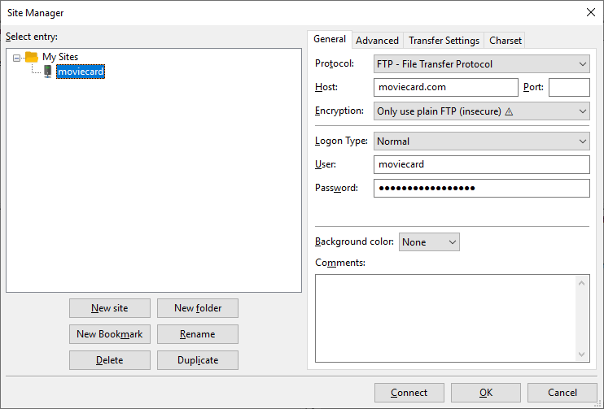

I’ll send the password in a separate email.

When you access the Moviecard Website site, just go to the top right side of the window (Remote site) and drag the bar down and click on **httpdocs.**

In the pane below that (bottom right pane), drag down and click the **gallery** folder. That’s your area, all the files in there are Gallery files. Everything else on the site is my moviecard site files, so don’t do anything to change any of those.

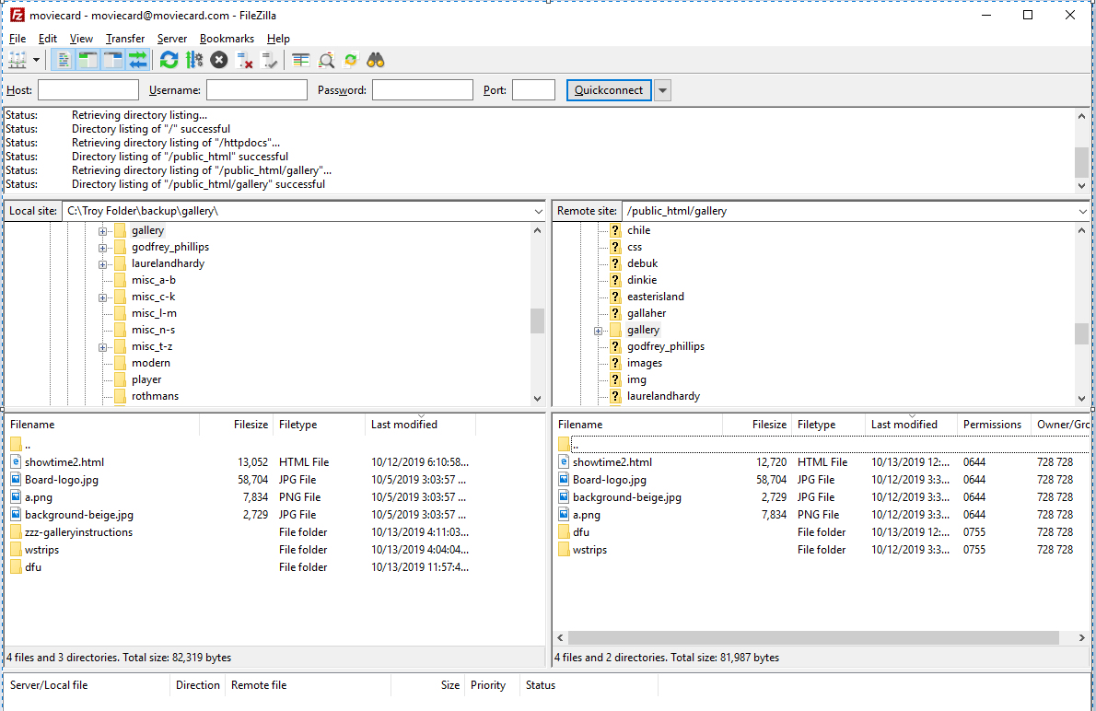

That’s about it. When you want to move files, just transfer from your computer to the gallery folder in the Moviecard Website.